**Practical – 4**

**Properties**

**Code:**

using System;

using System.Collections.Generic;

using System.Linq;

using System.Text;

using System.Threading.Tasks;

namespace Pract3

{

class TimePeriod

{

private double _seconds;

public double Hours

{

get { return _seconds / 3600; }

set

{

if (value < 0 || value > 24)

throw new ArgumentOutOfRangeException(

$"{nameof(value)} must be between 0 and 24.");

_seconds = value * 3600;

}

}

}

internal class Person

{

private string _firstName;

private string _lastName;

public Person(string first, string last)

{

_firstName = first;

_lastName = last;

}

public string Name => $"{_firstName} {_lastName}";

}

public class SaleItem

{

string _name;

decimal _cost;

public SaleItem(string name, decimal cost)

{

_name = name;

_cost = cost;

}

public string Name

{

get => _name;

set => _name = value;

}

public decimal Price

{

get => _cost;

set => _cost = value;

}

public int Quantity { get; set; }

}

internal class Properties

{

public static void Main()

{

Console.WriteLine("Vedant Joshi {0}\n\n",DateTime.Now);

TimePeriod t = new TimePeriod();

t.Hours = 24;

Console.WriteLine($"Time in hours: {t.Hours}\n");

var person = new Person("Vedant", "Joshi");

Console.WriteLine(person.Name);

var item = new SaleItem("Shoes", 19.95m);

Console.WriteLine($"\n{item.Name}: sells for Rs.{item.Price}\n");

item.Quantity = 10;

Console.WriteLine($"\nItem: {item.Name} | Cost: Rs.{item.Price} | Quantity: {item.Quantity} | Total Cost: {item.Quantity*item.Price}");

}

}

}

**Output:**

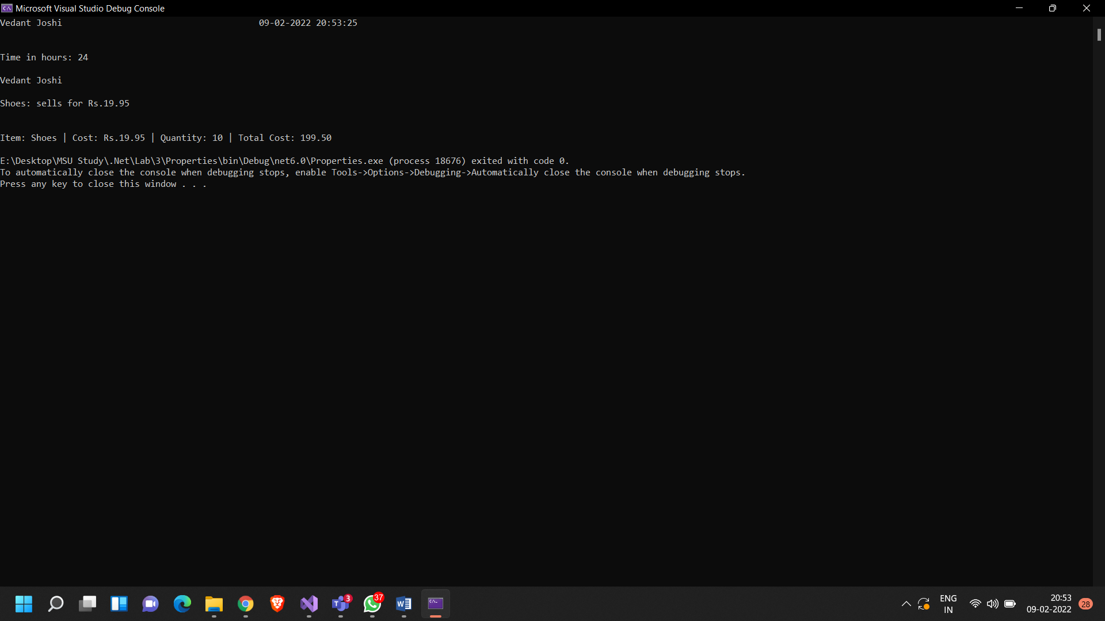

**Indexers**

**Code:**

using System;

using System.Collections.Generic;

using System.Linq;

using System.Text;

using System.Threading.Tasks;

namespace Indexers

{

public class TempRecord

{

// Array of temperature values

float[] temps = new float[10]

{

56.2F, 56.7F, 56.5F, 56.9F, 58.8F,

61.3F, 65.9F, 62.1F, 59.2F, 57.5F

};

// To enable client code to validate input

// when accessing your indexer.

public int Length => temps.Length;

// Indexer declaration.

// If index is out of range, the temps array will throw the exception.

public float this[int index]

{

get => temps[index];

set => temps[index] = value;

}

}

class DayCollection

{

string[] days = { "Sun", "Mon", "Tues", "Wed", "Thurs", "Fri", "Sat" };

// Indexer with only a get accessor with the expression-bodied definition:

public int this[string day] => FindDayIndex(day);

private int FindDayIndex(string day)

{

for (int j = 0; j < days.Length; j++)

{

if (days[j] == day)

{

return j;

}

}

throw new ArgumentOutOfRangeException(

nameof(day),

$"Day {day} is not supported.\nDay input must be in the form \"Sun\", \"Mon\", etc");

}

}

internal class Indexers {

public static void Main()

{

Console.WriteLine("Vedant Joshi {0}\n\n", DateTime.Now);

var tempRecord = new TempRecord();

// Use the indexer's set accessor

tempRecord[3] = 58.3F;

tempRecord[5] = 60.1F;

// Use the indexer's get accessor

for (int i = 0; i < 10; i++)

{

Console.WriteLine($"Element #{i} = {tempRecord[i]}");

}

var week = new DayCollection();

Console.WriteLine(week["Fri"]);

try

{

Console.WriteLine(week["Sat"]);

}

catch (ArgumentOutOfRangeException e)

{

Console.WriteLine($"Not supported input: {e.Message}");

}

}

}

}

**Output:**

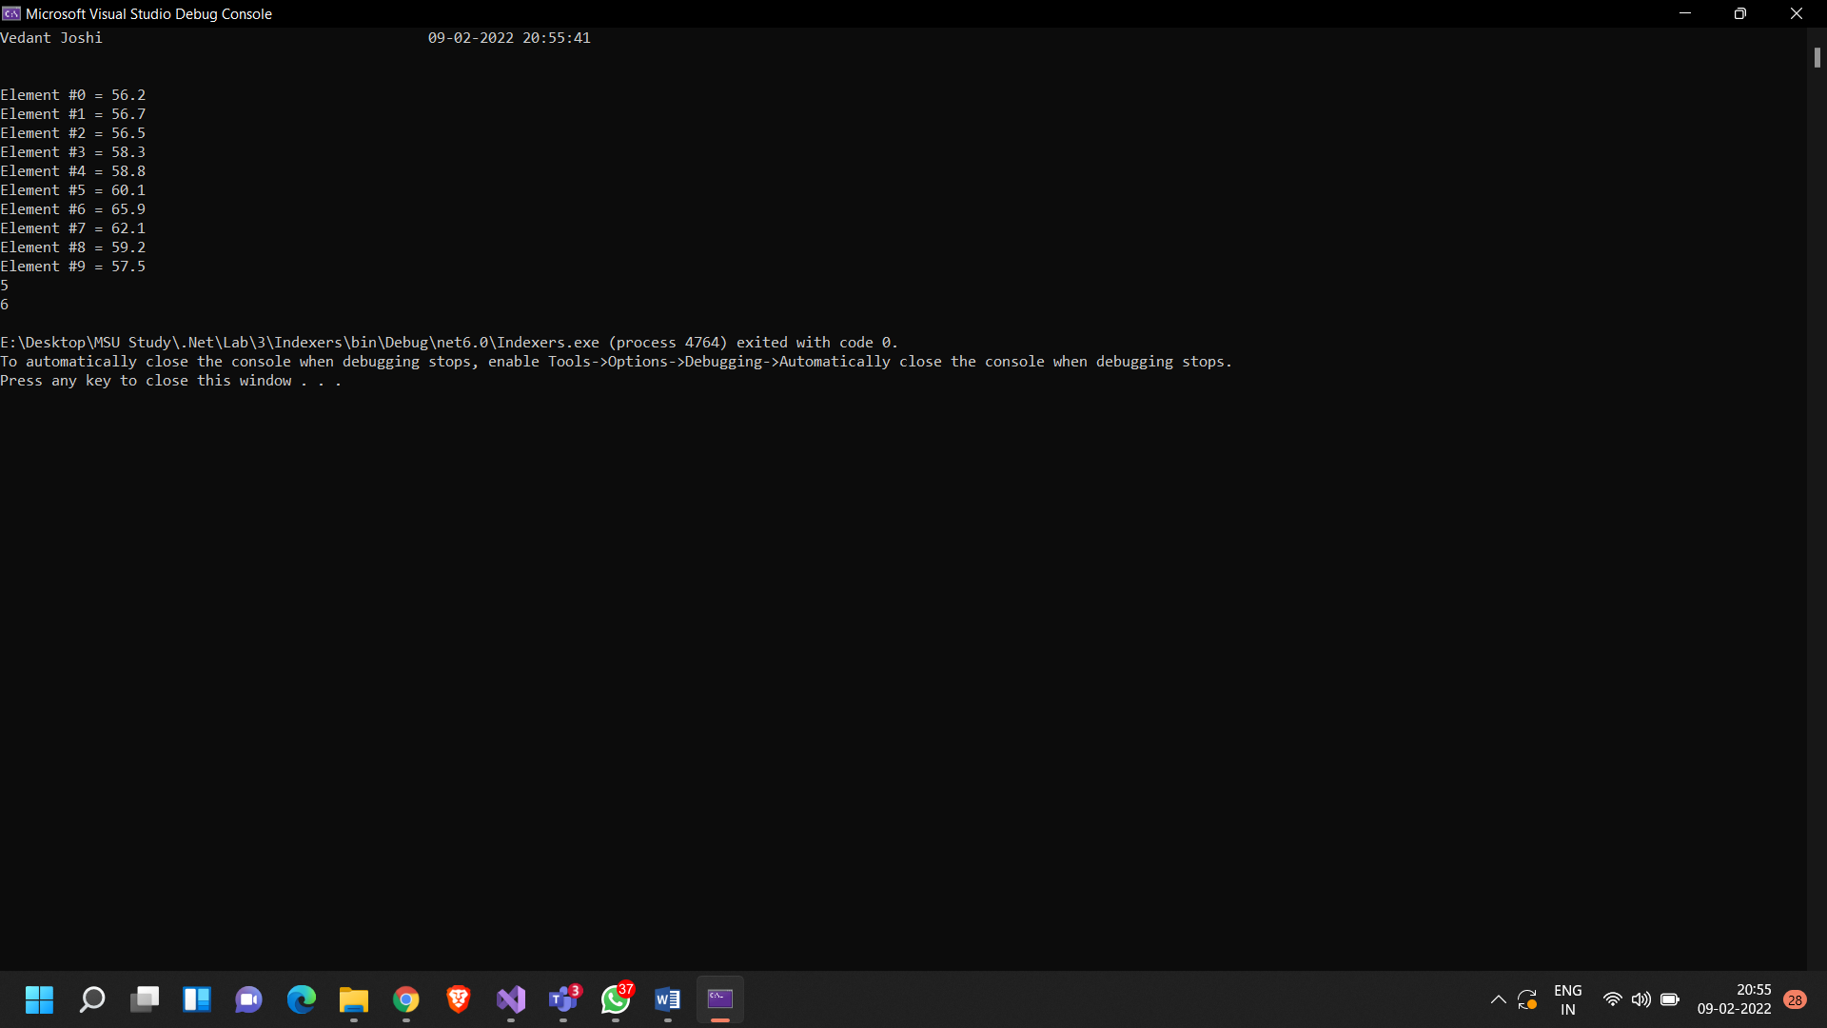

**Methods and Its Types**

**Code:**

using System;

using System.Reflection;

public class SimpleClass

{

public static void Main()

{

Console.WriteLine("Vedant Joshi {0}\n\n", DateTime.Now);

Type t = typeof(SimpleClass);

BindingFlags flags = BindingFlags.Instance | BindingFlags.Static | BindingFlags.Public |

BindingFlags.NonPublic | BindingFlags.FlattenHierarchy;

MemberInfo[] members = t.GetMembers(flags);

Console.WriteLine($"Type {t.Name} has {members.Length} members: ");

foreach (var member in members)

{

string access = "";

string stat = "";

var method = member as MethodBase;

if (method != null)

{

if (method.IsPublic)

access = " Public";

else if (method.IsPrivate)

access = " Private";

else if (method.IsFamily)

access = " Protected";

else if (method.IsAssembly)

access = " Internal";

else if (method.IsFamilyOrAssembly)

access = " Protected Internal ";

if (method.IsStatic)

stat = " Static";

}

var output = $"{member.Name} ({member.MemberType}): {access}{stat}, Declared by {member.DeclaringType}";

Console.WriteLine(output);

}

}

}

**Output:**

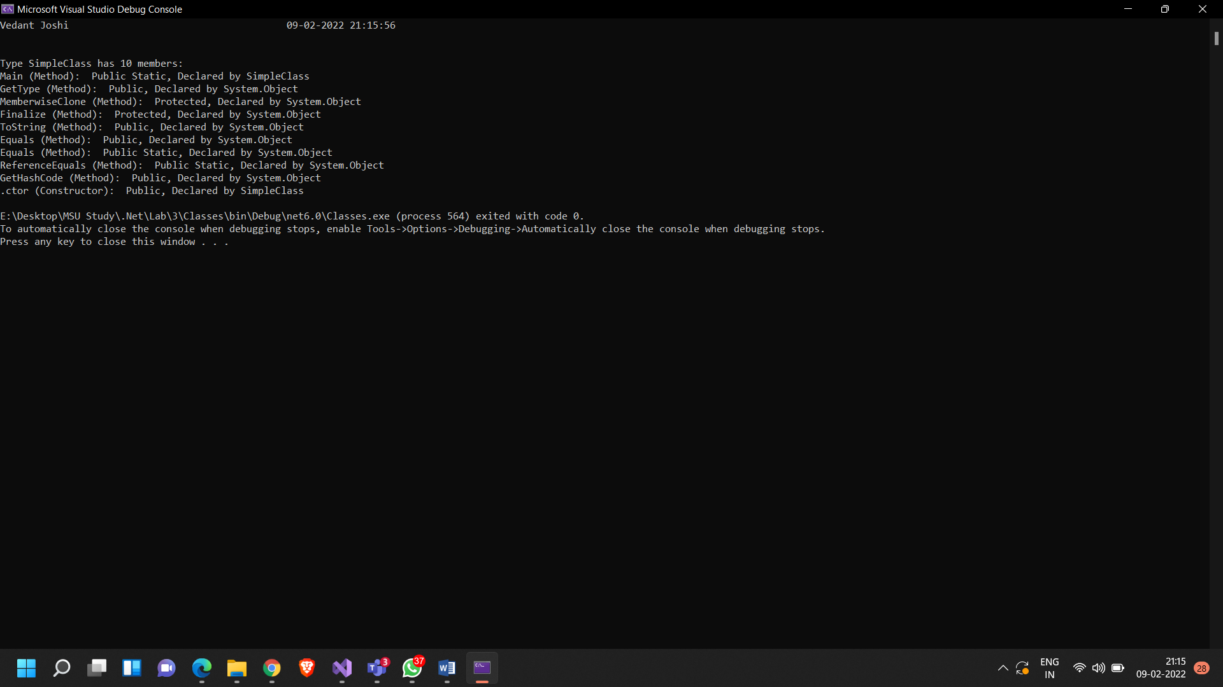

**Employee Class**

**Code:**

using System;

using System.Collections.Generic;

using System.Linq;

using System.Text;

using System.Threading.Tasks;

namespace Pract3

{

public class Employee

{

private string _firstName, _lastName;

private double _monthlySalary = 0.0, _yearlySalary = 0.0;

public Employee(string firstName, string lastName, double monthlySalary)

{

this._firstName = firstName;

this._lastName = lastName;

if (monthlySalary < 0) this._monthlySalary = 0.0;

else

{

this._monthlySalary = monthlySalary;

_yearlySalary = monthlySalary * 12;

}

}

public string FirstName

{

get

{

return this._firstName;

}

set

{

this._firstName = value;

}

}

public string LastName

{

get

{

return this._lastName;

}

set

{

this._lastName = value;

}

}

public double MonthlySalary

{

get

{

return this._monthlySalary;

}

set

{

if (value < 0)

{

this._monthlySalary = 0.0;

this._yearlySalary = 0.0;

}

else

{

this._monthlySalary = value;

this._yearlySalary = value*12;

}

}

}

public double YearlySalary

{

get => this._yearlySalary;

}

public virtual void giveRaise(double percentage)

{

this.MonthlySalary += (percentage/100) * this.MonthlySalary;

}

public override string ToString()

{

return $"----- Employee Details -----\nEmployee Name: {this._firstName} {this._lastName}\nMonthly Salary: {this._monthlySalary}\nYearly Salary: {this._yearlySalary}\n\n";

}

}

public class PermanentEmployee : Employee

{

private double _hra, _da, _pf;

private DateOnly _joiningDate, _retirementDate;

public PermanentEmployee(string firstName, string lastName, double monthlySalary, double hra, double da, double pf) : base(firstName, lastName, (monthlySalary+da+hra+pf))

{

_hra = hra;

_da = da;

_pf = pf;

}

public string getAllowances()

{

return $"Housing Rent Allowance: {this._hra}\nDearness Allowance: {this._da}";

}

public override void giveRaise(double percentage)

{

this.MonthlySalary += (percentage / 100) * (this.MonthlySalary+this._da+this._hra+this._pf);

}

public override string ToString()

{

return $"----- Employee Details -----\nEmployee Name: {this.FirstName} {this.LastName}\n{this.getAllowances()}\nProvident Fund: {this._pf}\nMonthly Salary: {this.MonthlySalary}\nYearly Salary: {this.YearlySalary}\n\n";

}

public string JoiningDate

{

get

{

return this._joiningDate.ToString();

}

set

{

this._joiningDate = DateOnly.ParseExact(value,"dd/mm/yyyy");

}

}

public string RetirementDate

{

get

{

return this._retirementDate.ToString();

}

set

{

this._retirementDate = DateOnly.ParseExact(value, "dd/mm/yyyy");

}

}

public double HRA { get => this._hra; }

public double DA { get => this._da; }

public double PF { get => this._pf; }

}

public class EmployeeTest

{

public static void Main()

{

Console.WriteLine("Vedant Joshi {0}\n\n", DateTime.Now);

Employee employee1 = new Employee("Emp", "A", 10000);

Employee employee2 = new Employee("Empl", "B", 15000);

Console.WriteLine(employee1);

Console.WriteLine(employee2);

employee1.giveRaise(10);

employee2.giveRaise(10);

Console.WriteLine("\nAfter giving 10% raise\n");

Console.WriteLine(employee1);

Console.WriteLine(employee2);

PermanentEmployee perEmp1 = new PermanentEmployee("PerEmp", "A", 17000, 3000, 2000, 5000);

PermanentEmployee perEmp2 = new PermanentEmployee("PerEmpl", "B", 20000, 3500, 3000, 7000);

Console.WriteLine(perEmp1);

Console.WriteLine(perEmp2);

perEmp1.giveRaise(10);

perEmp2.giveRaise(10);

Console.WriteLine("\nAfter giving 10% raise\n");

Console.WriteLine(perEmp1);

Console.WriteLine(perEmp2);

}

}

}

**Output:**

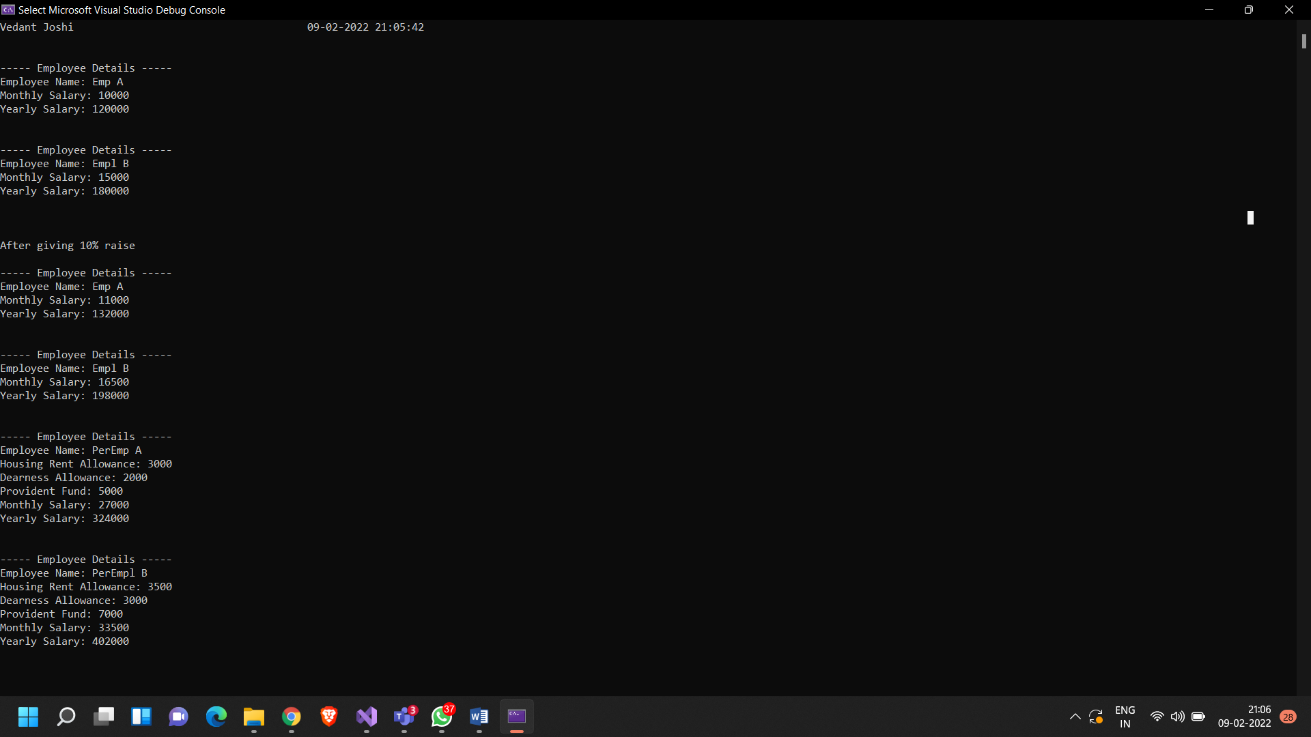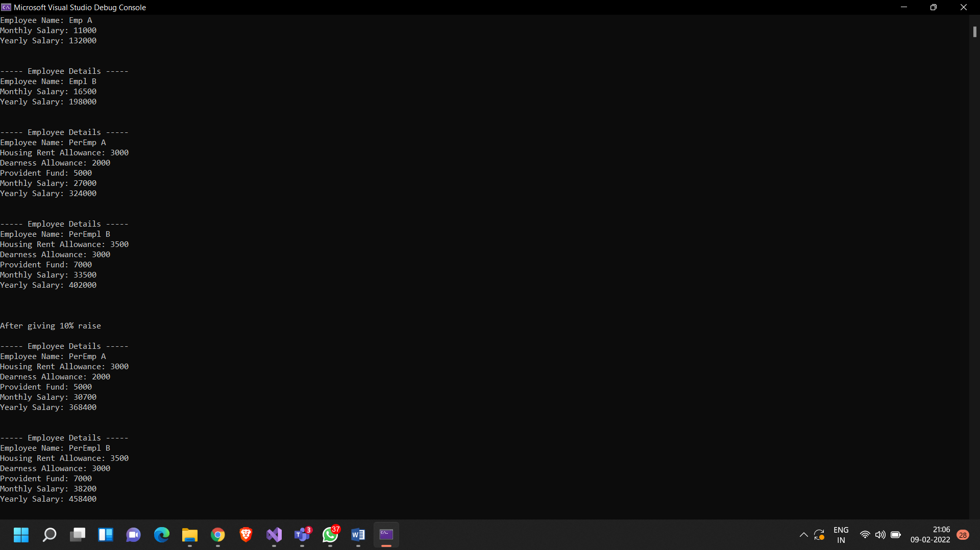

**Method Overloading and Method Hiding**

**Code:**

using System;

namespace Pract3{

public class A

{

public int getSum(int x, int y) {

return x + y;

}

public int getProduct(int x, int y)

{

return x * y;

}

}

public class B : A

{

public int getSum(int x, int y, int z)

{

return x + y + z;

}

new public int getProduct(int x, int y, int z)

{

return x * y * z;

}

}

public class Pract3

{

public static void Main()

{

Console.WriteLine("Vedant Joshi {0}\n\n", DateTime.Now);

A a = new A();

B b = new B();

Console.WriteLine("Printing from base class");

Console.WriteLine("A + B = {0}", a.getSum(10,20));

Console.WriteLine("A * B = {0}", a.getProduct(10, 20));

Console.WriteLine("Calling base class method from child class");

Console.WriteLine("A + B = {0}", b.getSum(10, 20));

Console.WriteLine("Printing from child class");

Console.WriteLine("A + B + C = {0}", b.getSum(10, 20, 30));

Console.WriteLine("A * B * C = {0}", b.getProduct(10, 20, 30));

}

}

}

**Output:**

